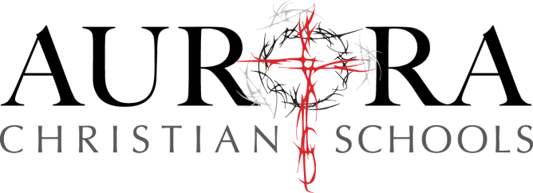

Aurora Christian High School Supply List 2017-2018

** All textbooks must be covered **
** Please do not use stretch fabric or adhesive book covers for textbooks **

General Items for All 9th- 12th Grade Students
- Book Bag
- Loose leaf Notebook Paper and Spiral Notebooks (college-ruled)
- Notecards (3x5)
- Pencils
- Pens
- Highlighter
- Two boxes of Kleenex
- ESV Bible (new students will be given a Bible)

Teachers will notify students of any specific course needs during the 1st week of school.

